**ASSIGNMENT-11**

**BATCH NO-1**

**25VID1334-DWS DATE-02-06-2025**

Step by step process of ACT, Event Viewer ,Process Monitor and Dependency Walker.

1. **ACT (Application Compatibility Toolkit):**

The Microsoft Application Compatibility Toolkit (ACT) is a tool that assists in identifying and managing your overall application, reducing the cost and time involved in resolving application compatibility issues and helping us quickly to deploy Windows and Windows updates.

* Benefits of Microsoft Application Compatibility Toolkit (ACT)
* **Simplifies Application Compatibility Management**
  + Helps identify and manage applications, reducing the time and cost to resolve compatibility issues and making Windows deployment smoother.
* **Comprehensive Analysis**
  + Allows analysis of applications, websites, and computers to ensure compatibility across your entire IT ecosystem.
* **Manage Applications & Configuration Settings**
  + Provides centralized management of application compatibility and configuration settings, ensuring consistency across your enterprise.
* **Prioritize Compatibility Issues**
  + Offers filtered reporting, enabling you to prioritize and focus on the most important compatibility challenges first.
* **Track & Resolve Compatibility Issues**
  + Easily add, manage, and resolve issues to ensure a smooth user experience across your organization.
* **Collaborate with Microsoft**
* Seamlessly send and receive compatibility data from Microsoft, ensuring access to the latest solutions and updates for your environment.

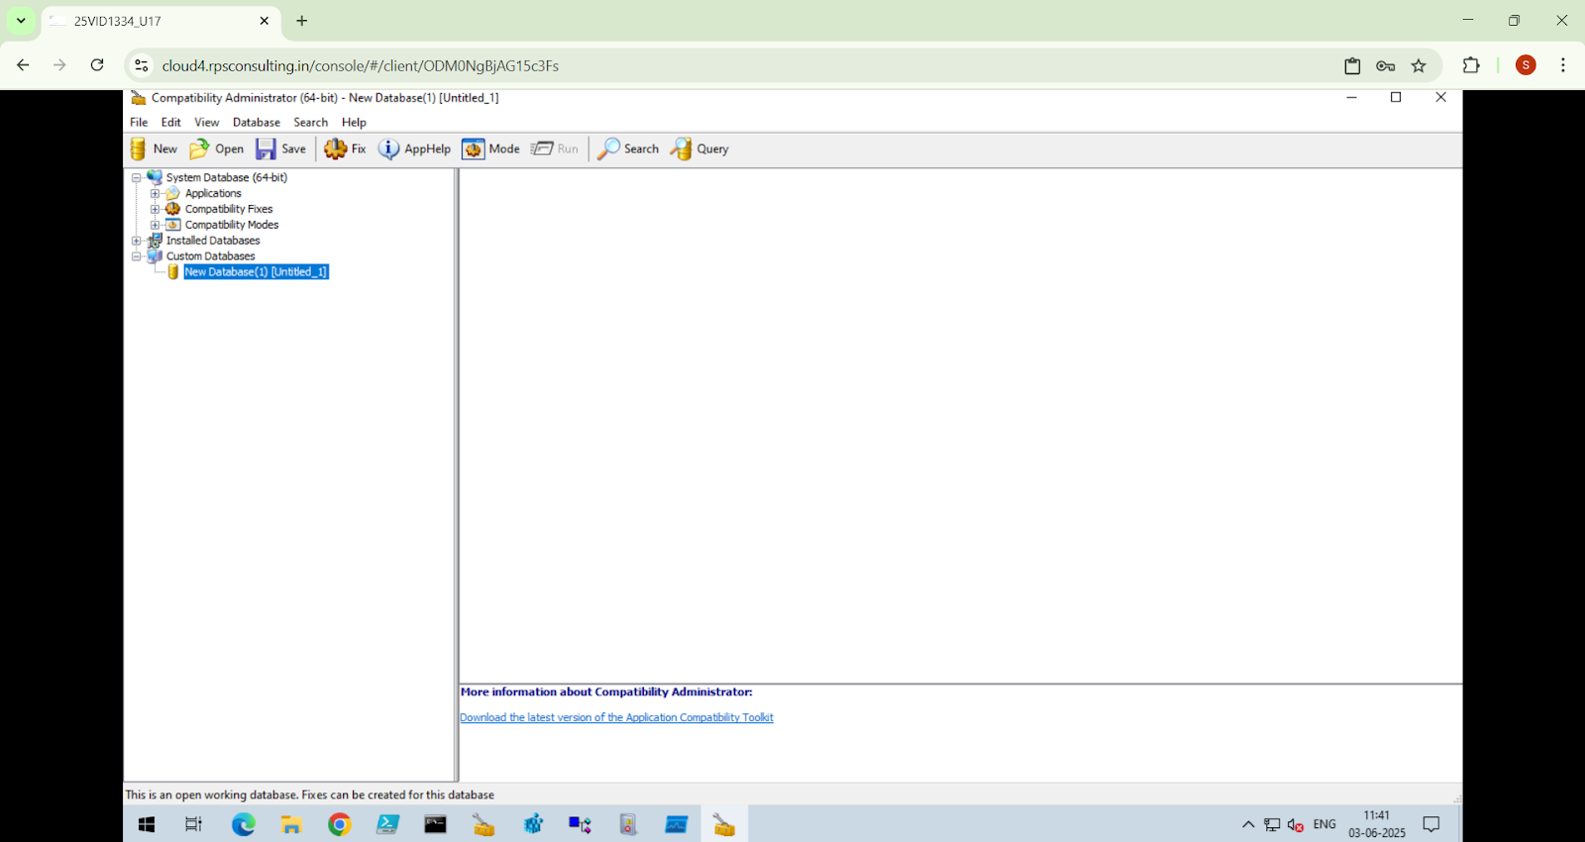

Step by step process of ACT:

Here’s a concise and perfect version**:**

Steps to Use Microsoft Application Compatibility Toolkit (ACT)

* Download ACT: **link** [**learn.microsoft.com/en-us/windows-hardware/get-started/adk-install#download-the-adk-101261002454-december-2024**](http://learn.microsoft.com/en-us/windows-hardware/get-started/adk-install#download-the-adk-101261002454-december-2024)
* Run Setup:  
  Run adksetup.exe to create a Windows Kits folder.
* Navigate to Installers:  
  Go to Windows Kits\10\ADK\Installers, search for Application Compatibility Toolkit.
* Install Toolkit:  
  Install the appropriate version (32-bit or 64-bit).
* Open Compatibility Administrator:  
  Launch Compatibility Administrator (32-bit/64-bit).
* Create New Fix:  
  Click Database > Create New > Application Fix.
* Provide Program Details:  
  Enter program name and browse to the .exe file, then click Next.
* Skip Compatibility Modes:  
  Click Next (no changes).
* Select Compatibility Fixes:  
  Check ForceAdminAccess, CorrectFilePaths, and any other required options, then click Next.
* Save Database:  
  Save the file as MyFixess.sdb.
* Install via Command Prompt:  
  Run in Command Prompt as Administrator:
* sdbinst "C:\Users\admin\Downloads\MyFixess.sdb"

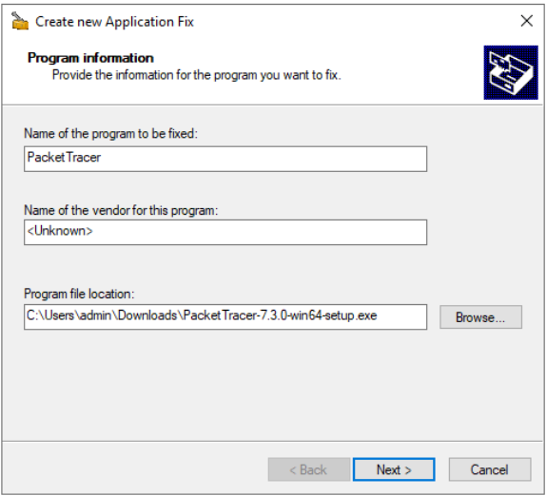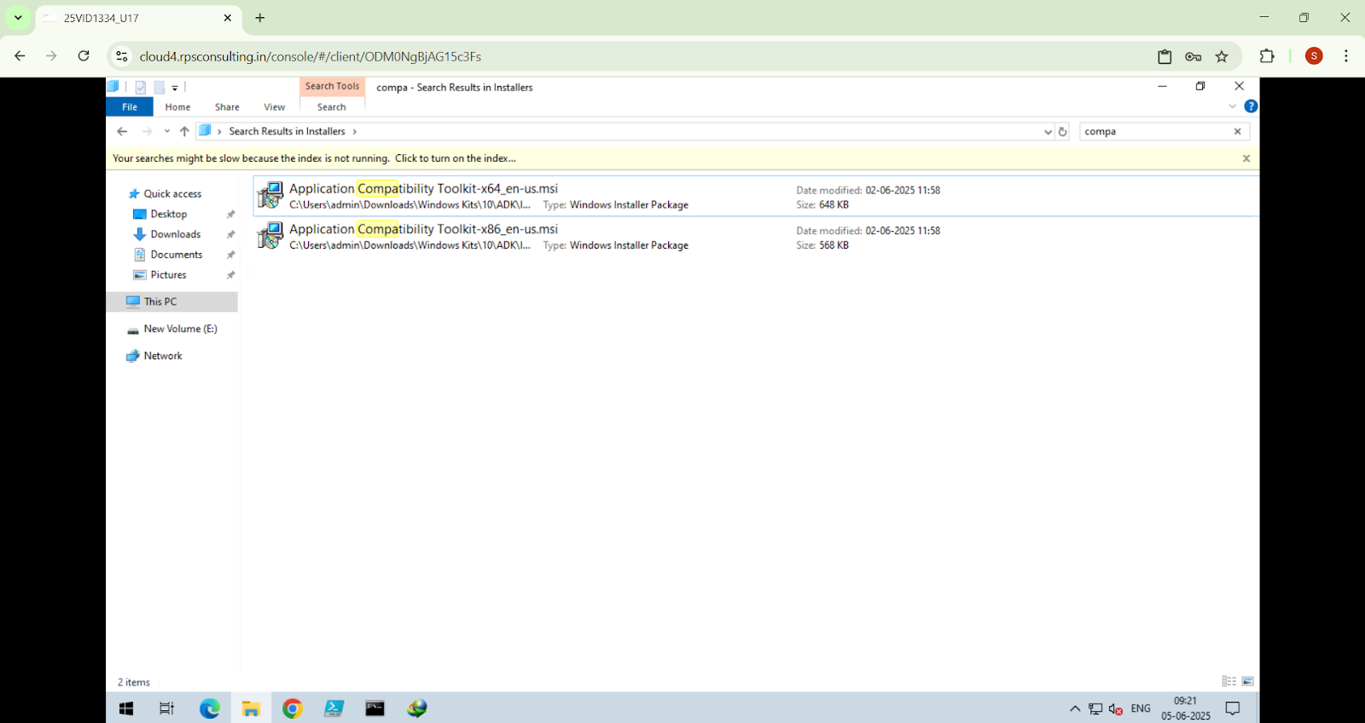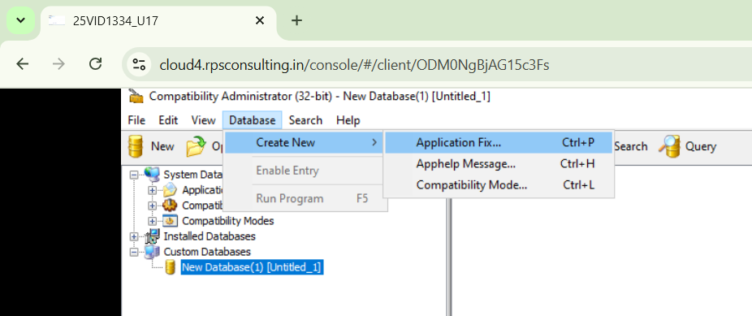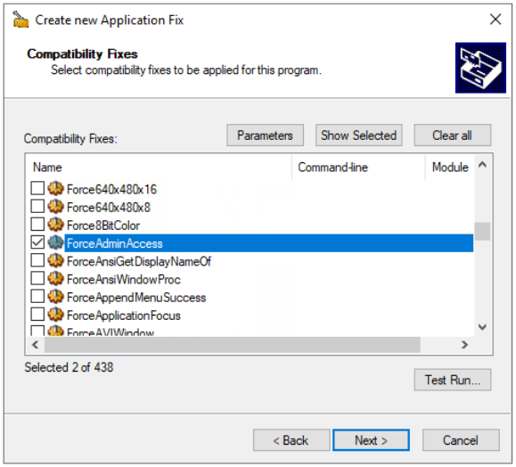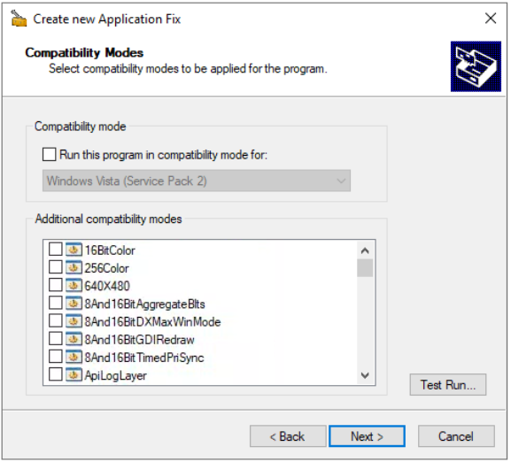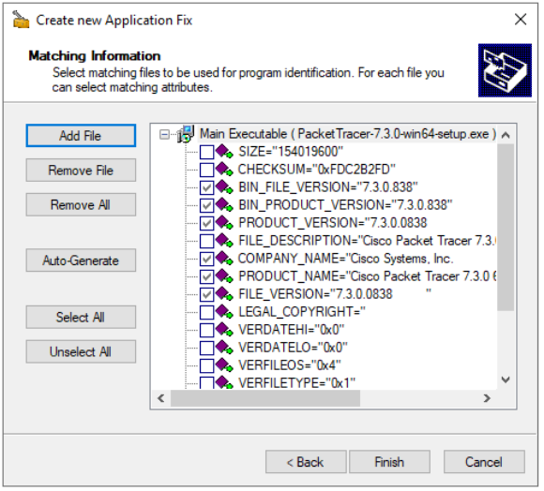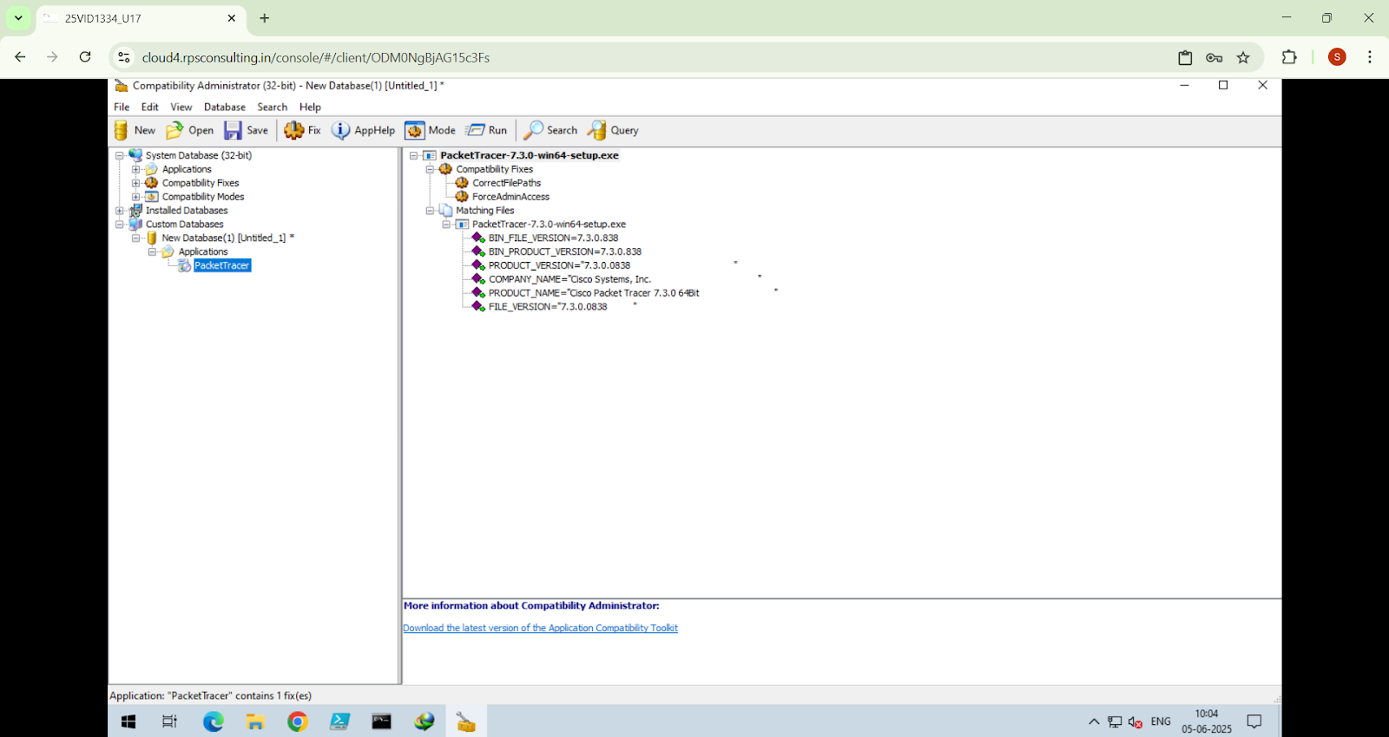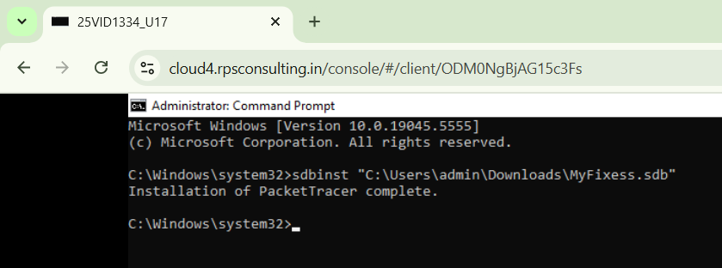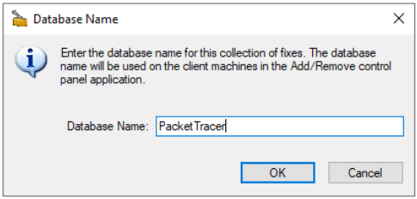

2.Process Monitor:

* **Launch Process Monitor** – A tool for real-time monitoring of file system, registry, and process/thread activity.
* **Combines Legacy Tools** – Merges functionality from Filemon and Regmon.
* **Real-Time Tracking** – Captures detailed system activity as it happens (file access, registry changes, process behavior).
* **Use Filters** – Narrow down to specific processes or operations for focused analysis.
* **Diagnose Issues** – Pinpoint problems with app startup, file access, or system performance.
* **Analyze Interactions** – Offers insights into system behavior for troubleshooting.

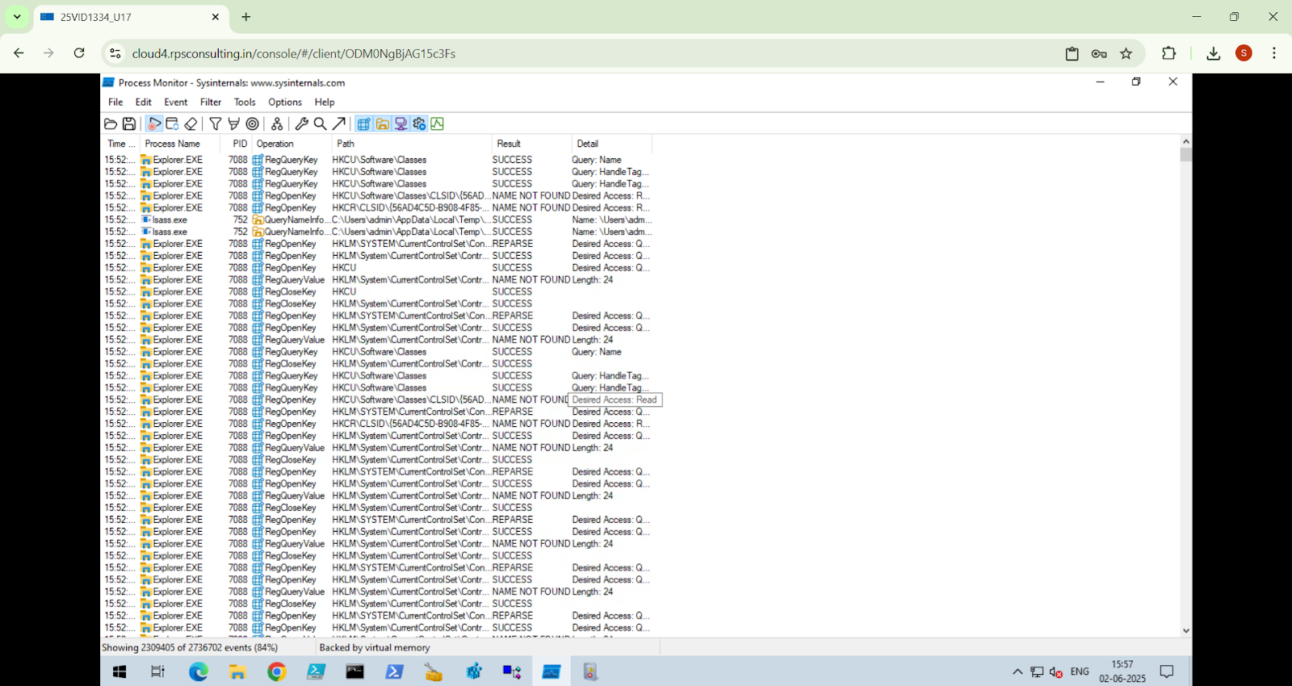

Step by step process of Process Monitor:

* **Download the Process Monitor from the link** <https://learn.microsoft.com/en-us/sysinternals/downloads/procmon>
* Extract the zip files and run the Procmon.exe file.
* To filter the processes click on the Filter option (or use Ctrl+L) and then a window will appear, in that select the appropriate parameters for filtering.

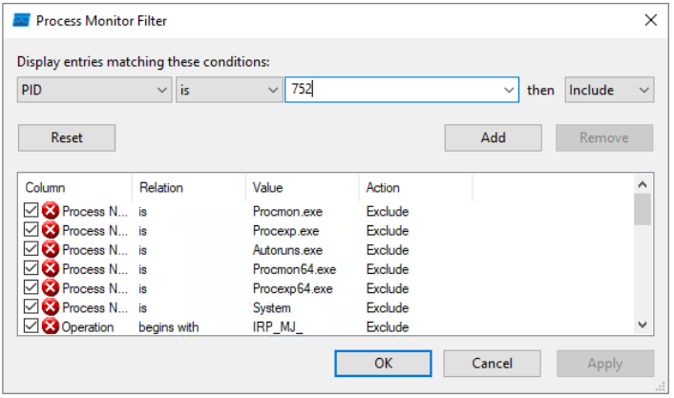

* Example: PID in first dropdown, is in second dropdown, 752 in third dropdown, Include in fourth dropdown, then press OK.
* Then a dialog box comes asking You did not add the item you were editing. Add it now? So press Yes.

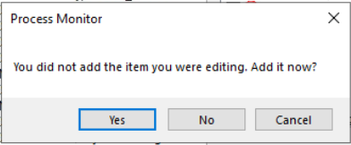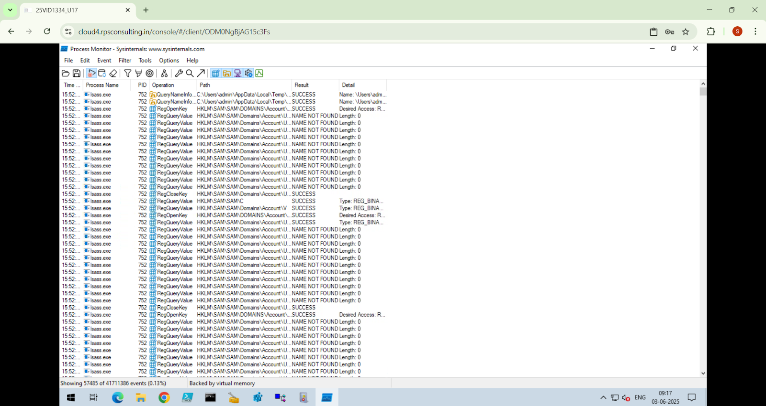

3.Event Viewer:

* Event Viewer is used to identify the System-Level Errors related to the installation.
* It is used for troubleshooting problems, monitoring security events, diagnosing system or application errors and more.
* Its functions are to log system events including errors, warnings and information messages.
* It searches for relevant error messages, warnings or event IDs to understand the nature of the problem.
* It provides a historical record of system activity, helping to identify recurring problems and pinpoint the source of errors.

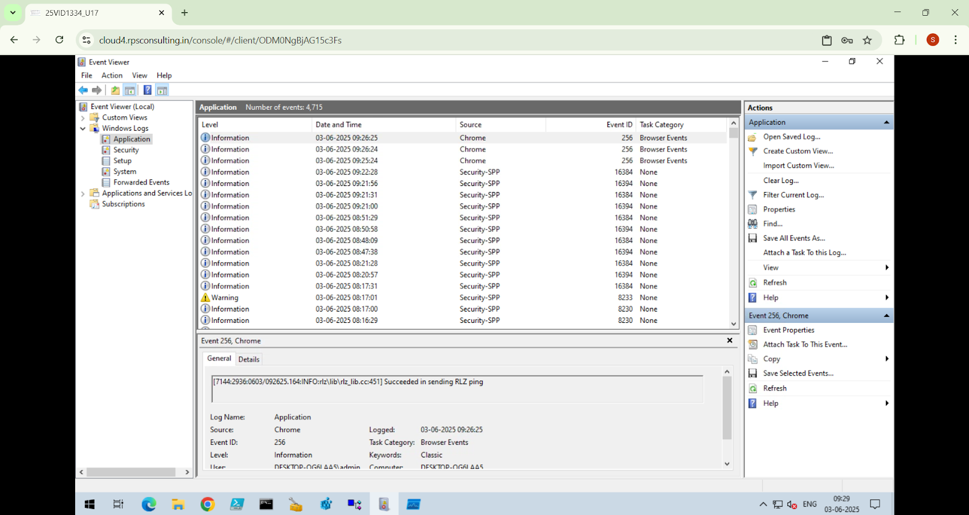

Step by step process of Event Viewer:

* Open Event Viewer from the Start Menu.
* Navigate to the Windows Logs and expand it, in that Application, Security, Setup and System are available, so select the one where events will be present. For eg. in the Application, 4715 Events are present.
* In the Actions pane (right side), click Filter Current Log.

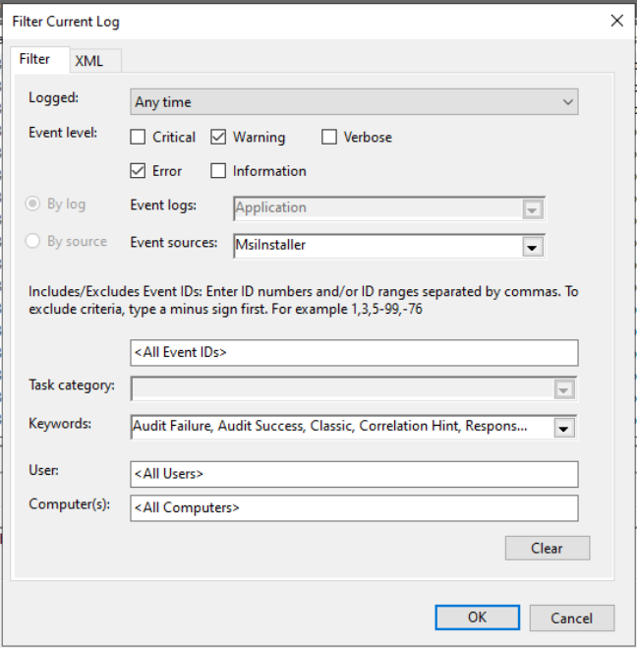

* In the Filter Current Log window, under Event sources select MsiInstaller. We can also filter by Event level for eg. Error, Warning to narrow down the results. Also under Keywords we can select All keywords and then click OK to apply the filter.
* Analyze the Event to identify the cause of MSI installation error (in the bottom pane).

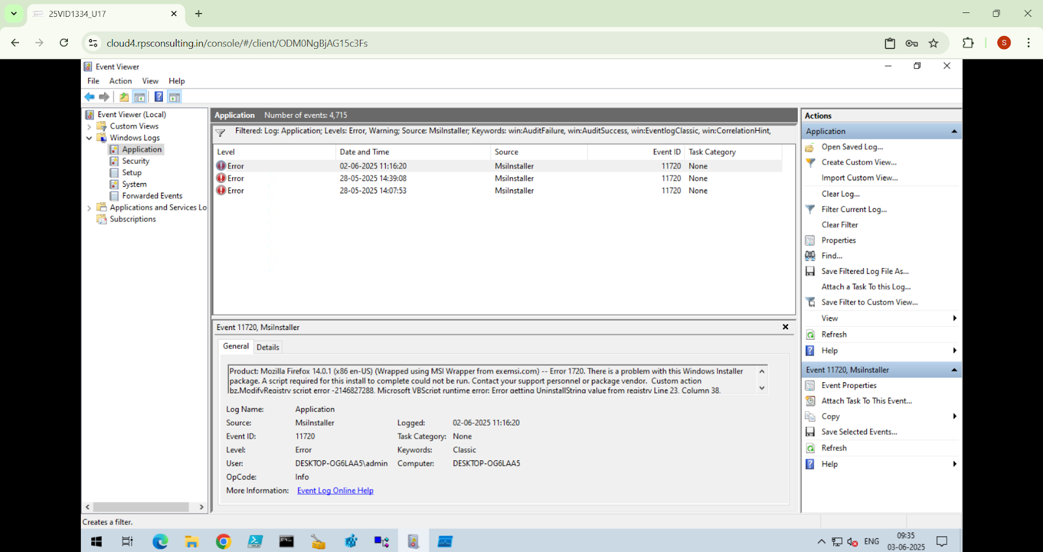

4.Dependency walker:

Dependency Walker is a Windows tool used to analyze and troubleshoot application dependencies. It helps identify missing or incorrect DLLs, displays a hierarchy of dependencies, and provides detailed information on imported/exported functions, making it essential for resolving issues like "missing DLLs" or "entry point not found."

* **Tool** for analyzing Windows app dependencies.
* Identifies **missing or incorrect DLLs**.
* Shows a **hierarchical list** of dependencies.
* Works with **32-bit and 64-bit** applications.
* Detects errors like **"missing DLLs"** or **"entry point not found"**.
* Provides detailed info on **imported/exported functions**.
* **Static analysis** (doesn't execute the program).
* 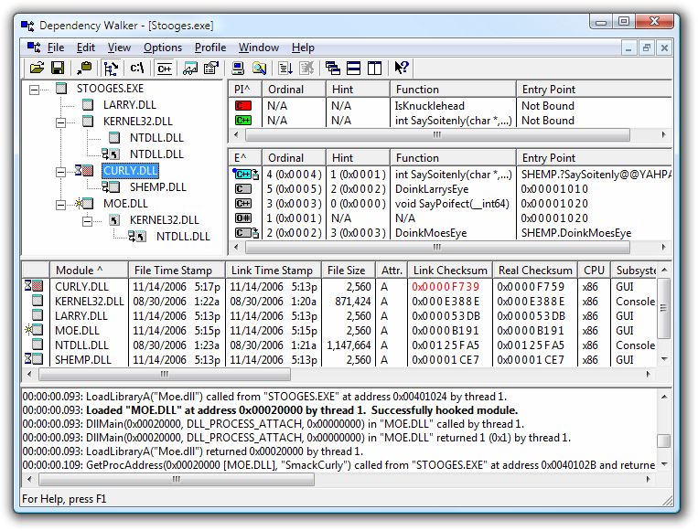

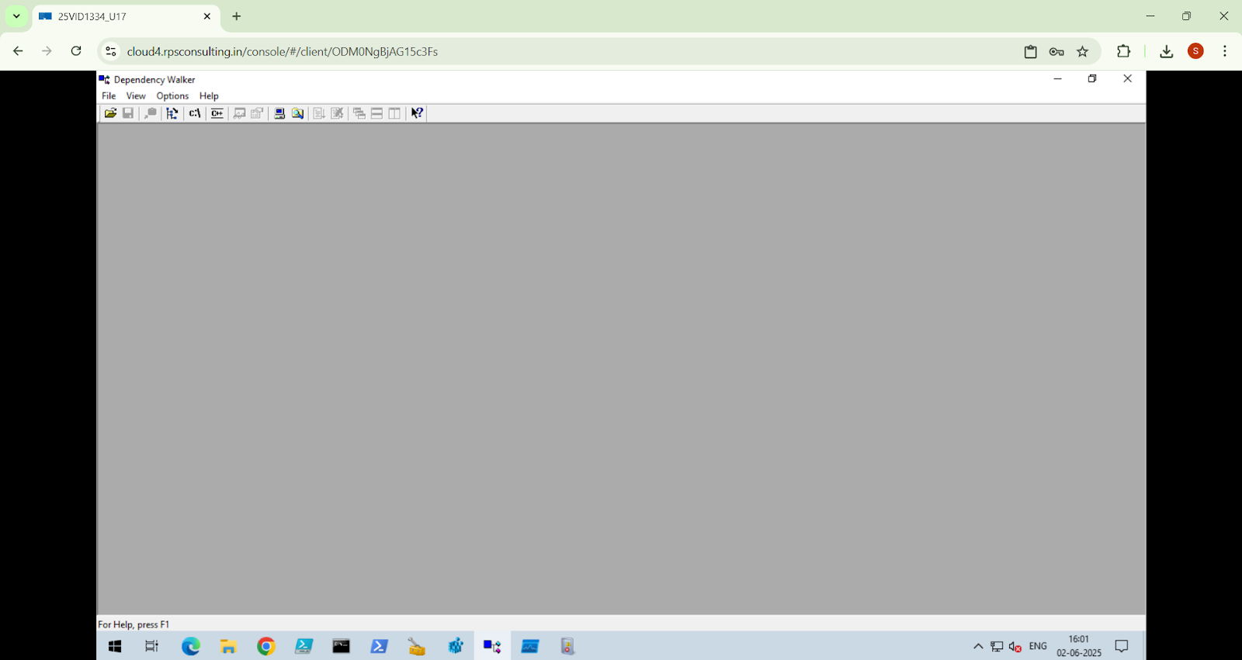

Step by step process for Dependency Walker:

* You can download Dependency Walker from its official website:
* Download Link:
* https://www.dependencywalker.com/depends22_x86.zip
* Visit the link above.
* Scroll down to find the "Download" section.
* Choose the latest version and download the ZIP file.
* Extract the ZIP file and run the depends.exe executable to start using Dependency Walker.

